Ecole Centrale de Nantes
Nantes
EMARO1-ARIA1 Master

Lab No1: Manipulator modelling

1. Analysis of the two functions InvTransHom.m and DHSym.m

DHSym.m

This function is used to generate the symbolic transformation matrix. The function has four arguments which are the parameters used in Modified Denavit-Hartenberg convention.

Alpha :represents the rotation between z_{k-1} and z_{k} around the x_{k-1} axis
d :represents the translation between z_{k-1} and z_{k} along the x_{k-1} axis
theta :represents the rotation between x_{k-1} and x_{k} around the z_{k} axis
r :represents the translation between x_{k-1} and x_{k} along the z_{k} axis

- Number of joints is calculated from the length of the matrix ‘alpha’ but this can also be found out by using the length of the remaining parameters.
- An identity matrix TOTn is defined to store the final transformation matrix.
- Then an iteration starts from the number of joints down to 1 to find out the transformation matrix of the reference frame R_{n} with respect to the reference frame R₀ .
- The inverse transformation matrix is stored in ‘IT’ which is find out by invoking the function InvTransHom(T). This is useful in computing the inverse geometric model of robot.

InvTransHom.m

This funtion is used to find out the inverse transformation matrix which shows the transformation of frame R₀ with respect to frame R_{n} . This function takes matrix ‘T’ as argument which is produced in the function DHSym(alpha, d, theta, r).
This function extracts the Position matrix ‘P’ and Orientation matrix ‘R’ and operates on it to create the Inverse Transformation matrix .

IT=( R^{t} -R^{t}*P)
(000 1 )

IT=Inverse transformation matrix.
R^{t} =Transpose of orientation matrix R.
P = Position matrix.

2. Modeling of the R3 plan robot

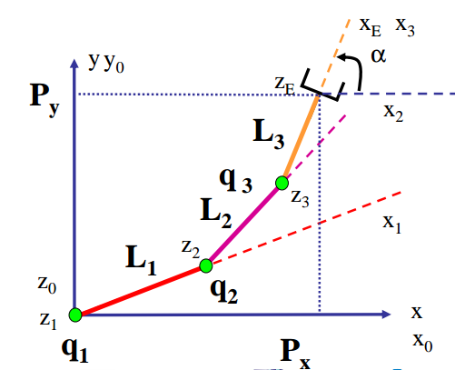

Figure 1: r3plan manipulator robot

 | σk | αk | dk | θk | rk
R0=>R1 | 0 | 0 | 0 | q1 | 0
R1=>R2 | 0 | 0 | L1 | q2 | 0
R2=>R3 | 0 | 0 | L2 | q3 | 0
R3=>Re | 0 | 0 | L3 | 0 | 0

Modified Denavit-Hartenberg parameter table

- r3plansym.m to compute the direct geometrical model

clear; clc;
syms L1 L2 L3 q1 q2 q3;
alpha = sym([0 0 0 0]);
d = [0 L1 L2 L3];
theta = [q1 q2 q3 0];
r = [0 0 0 0];
T0E = DHSym(alpha, d, theta, r);
Px = T0E(1,4);
Py= T0E(2,4);
alp = q1 + q2 + q3;

- Position and orientation of the end effector in the plane

Px = L2*cos(q1 + q2) + L1*cos(q1) + L3*cos(q1 + q2 + q3);
Py = L2*sin(q1 + q2) + L1*sin(q1) + L3*sin(q1 + q2 + q3);
alpha = q1 + q2 + q3;

- mgd.m

disp('Enter the joint space values );
q1=input('q1 = ');
q2=input('q2 = ');
q3=input('q3 = ');
q=[q1;q2;q3];

Px = L2*cos(q1 + q2) + L1*cos(q1) + L3*cos(q1 + q2 + q3);
Py = L2*sin(q1 + q2) + L1*sin(q1) + L3*sin(q1 + q2 + q3);
alpha = q1 + q2 + q3;

xf=[Px;Py;alpha]

qsol=[q1;
q2;
q3]

nbsolution=1

2.2 IGM: direct geometrical model

- mgi.m

disp('Enter the position and orientation of end effector');
Px = input('Px = ');
Py = input('Py = ');
alpha = input('alpha = ');

Z1 = Px -cos(alpha).*L3;
Z2 = Py -sin(alpha).*L3;
X = L1; Y = L2;
Cth = (Z1^2 + Z2^2 -X^2 -Y^2)/(2*X*Y);

q21=atan2(sqrt(1-Cth^2),Cth);
q22=atan2(-sqrt(1-Cth^2),Cth);

B11 = X + Y*cos(q21);
B12 = Y*sin(q21);

B21 = X + Y*cos(q22);
B22 = Y*sin(q22);

sth11 = (B11*Z2 - B12*Z1)/(B11^2+B12^2);
cth11 = (B11*Z1 + B12*Z2)/(B11^2+B12^2);

sth12 = (B21*Z2 - B22*Z1)/(B21^2+B22^2);
cth12 = (B21*Z1 + B22*Z2)/(B21^2+B22^2);

q11=atan2(sth11,cth11);
q12=atan2(sth12,cth12);

% Computing theta3
q31=alpha-q21-q11;
q32=alpha-q22-q12;

qsol=[q11,q12;
q21,q22;
q31,q32];

if (q21 == 0 & q22 == 0 )
nbsolution = 1
else
nbsolution = 2
end;

